Types of Interjections
# Source: AI Source: Provided by: [Data Path: Persons Table -> ID Column: 1, Name_En Column: Motasem Essam] -> From: [Chatgpt (GPT-4-turbo)] on [7/28/2025]
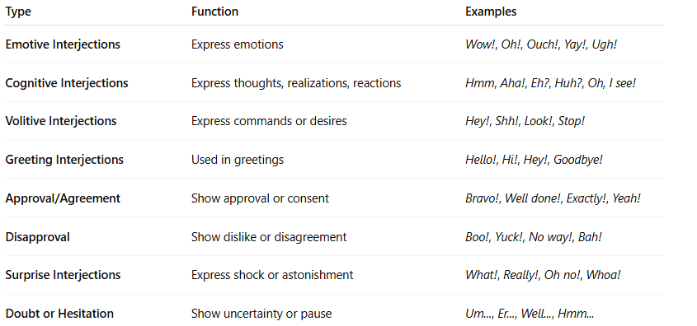

Type | Function | Examples
Emotive Interjections | Express emotions | Wow!, Oh!, Ouch!, Yay!, Ugh!
Cognitive Interjections | Express thoughts, realizations, reactions | Hmm, Aha!, Eh?, Huh?, Oh, I see!
Volitive Interjections | Express commands or desires | Hey!, Shh!, Look!, Stop!
Greeting Interjections | Used in greetings | Hello!, Hi!, Hey!, Goodbye!
Approval/Agreement | Show approval or consent | Bravo!, Well done!, Exactly!, Yeah!
Disapproval | Show dislike or disagreement | Boo!, Yuck!, No way!, Bah!
Surprise Interjections | Express shock or astonishment | What!, Really!, Oh no!, Whoa!
Doubt or Hesitation | Show uncertainty or pause | Um..., Er..., Well..., Hmm...

